Handout 2A: Name the Parts
Draw a line from objects in the left column to the right column. The first one has been done for you.
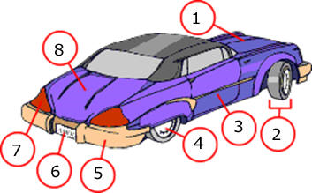 | - Hood

(Pictures from http://www.languageguide.org/im/car/eng/ )

